Design documentation

- Concept Map

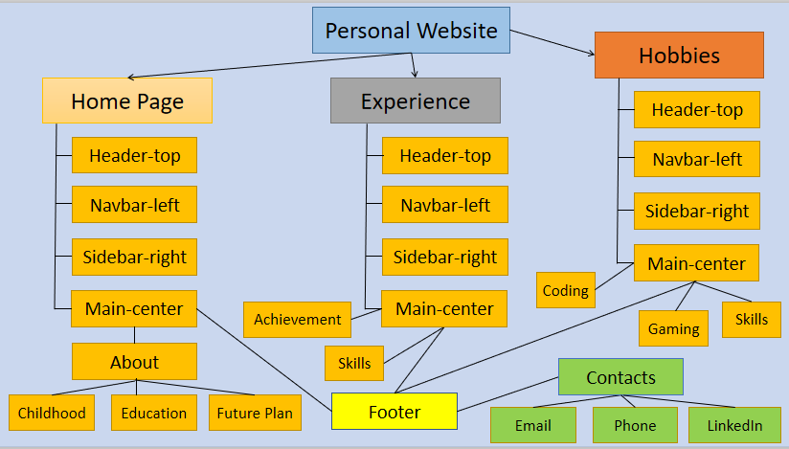

- CSS Design

Header



Nav bar (floating left with CSS buttons as per the requirements along with logo at the bottom)

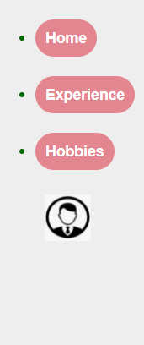

Main-page (along with navbar, sidebar and footer at the bottom of the page)

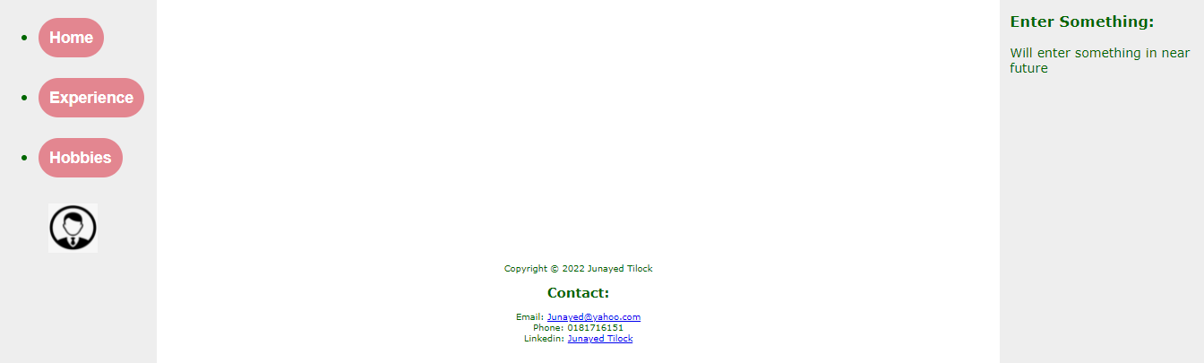

Table (with captions)

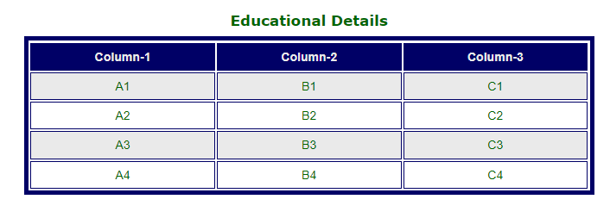

3. Navigation Map (Logical)

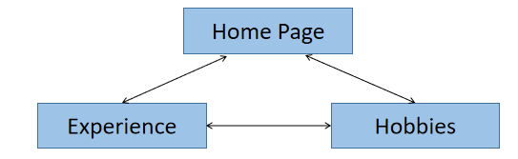

4. Structure Chart (Physical)

The physical structure is a 3 column layout as follows

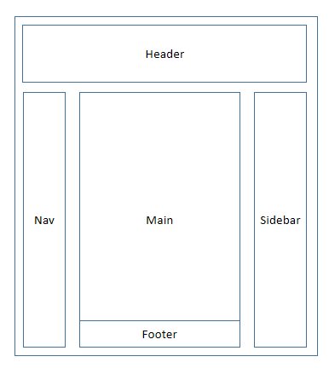

- Storyboards

Home page

Person Name
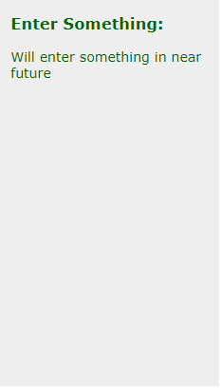
Logo
News/ Blog-1
News/ Blog-2
About
Childhood
Education
Future Plan
Footer (with Contact details)

Experience page

Person Name
Logo
News/ Blog-1
Resume PDF file
Achievement
Table for Achievements
Footer (with Contact details)
Skills
Table for Skills

Hobbies Page

Person Name
Logo
News/ Blog-1
Resume PDF file
Coding
Footer (with Contact details)
Gaming
Skills

- Testing Plan

- Scope of project

As the software requirement specifications, the project only focus on testing all the functions and external interface of the portfolio website (in scope testing, browser and device report, responsive report, etc).

Knowing which browsers and devices are within the project’s specification will help us to focus and reduce the development time and costs.

Nonfunctional testing such as stress, performance or logical database (such as information within the about or the experience section) currently will not be tested (out of scope).

- Timeline

We will also include testing of the project’s timeline. This is crucial for getting things done on time.

Complete initial testing will be done within one day, with feedbacks by the user completed on the same day.

Two days for fixing bugs a further half day for retesting bugs.

- Details of page functionality

We finally test the CSS and the Navigation between the webpages to ensure smooth functioning of the website. If things get added later on then we will test the layout of the site again.

